Building “stand alone vue app”.

Using Vue-CLI (command line tool)

$ npm install -g vue-cli //install vue-cli globally

$ vue init webpack myapp //create new project with webpack template

$ cd myapp

$ npm install //install dependencies

$ npm run dev //run dev server

$ npm run build //Build application to production

Next try creating a parameter “msg” in our app object.

And let msg = “<h1>Vue says Hi!</h1>”; and see what happens

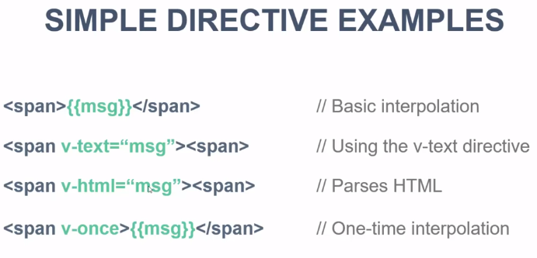

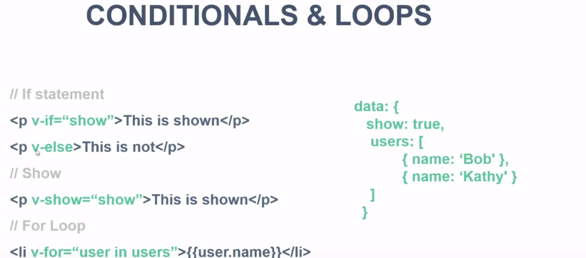

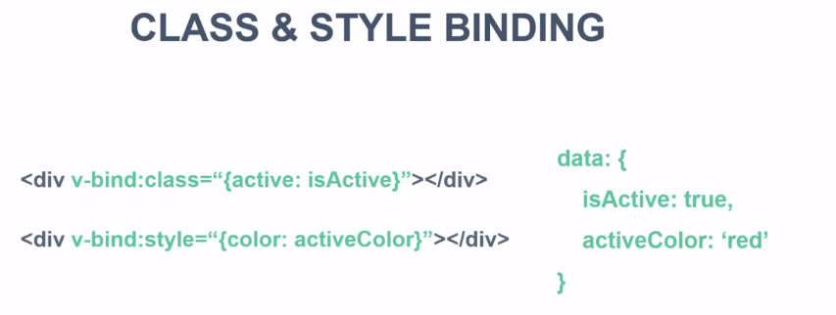

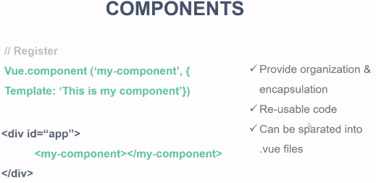

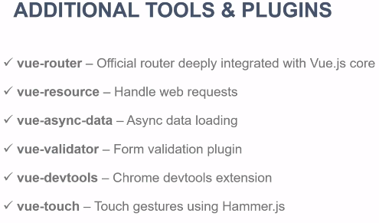

Change port: 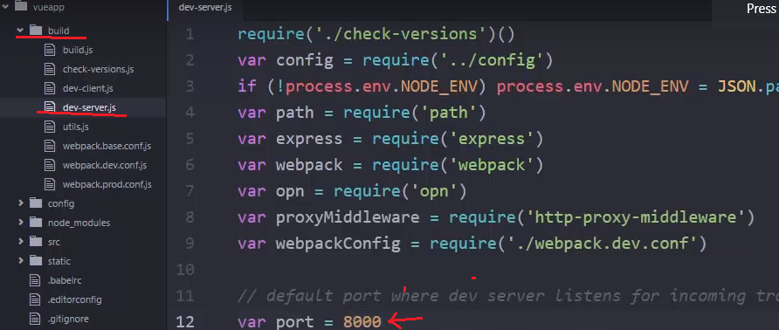

SRC > Main.js is where we start.

Maybe install “Vetur” addon.

Adding new Component “Users”

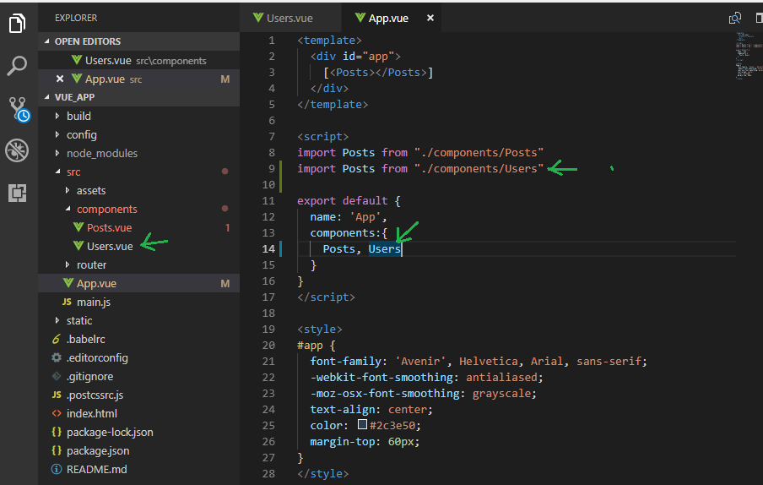

Adding User JSON service. **We use “Vue Resource”**

To do that, we need to install “vue resource” via NPM

Stop debug (ctrl+c)

$ npm install vue-resource –save

Run dev again npm run dev

And to use it:

1. Import to Main.js
2. 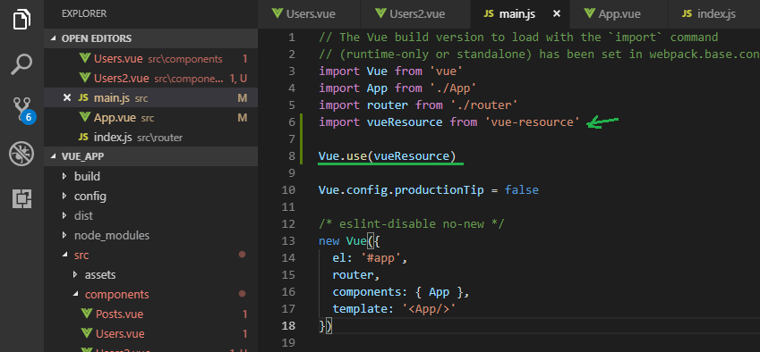

And start using the service

Use “created” event or similar.

Vue Router

Adding: npm install vue-router --save

Adding import to Main.js

